## USER DOCUMENTATION

This is the reference document to users who are going to use this system to online seafood management functionalities.

This system has two different types of users such as Administrator and customer. Accessing privilege also vary from one user type to another.

Since the Administrator has the full privilege to operate all the modules. Here this document is organized for the user those who have the Administrative privilege.

LOGIN

Type the following URL in the address bar (Figure 1) provided the home page (Figure 2).



Figure 1 Address bar with URL for Thulasy fancy

Figure 2 Home Page/Index

The following modules can be accessed by any user without logging into the system

* All of the offered items can be seen.
* All of the items which are available in the shop but order cannot be placed.
* Login to the system.

Clicking on the “Login” provides the login page (Figure 3).

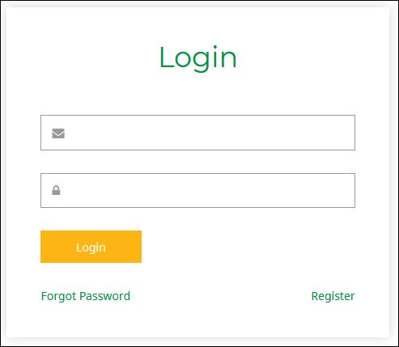

Figure 3 Login page

In addition, index page is facilitated to login, forget password, logout and register customer. From login, only registered users will be allowed to enter our system. When registered user enters wrong username or password the system will show an error message. System will allow only three attempts in case of miss feed of user name or password. It is shown on the following Figure 4

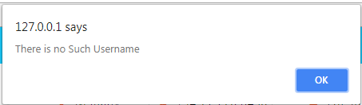

Figure 4 Username error

Password error is shown on the following Figure 5

Figure 5 Password error

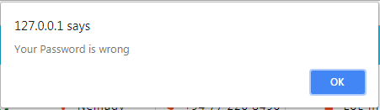

Enter incorrect password more than three times, error message shown the following figure 6 and leads to forget password page shown as figure 7.

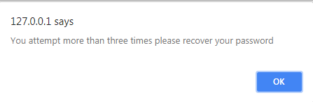

Figure 6 incorrect attempt more than three times

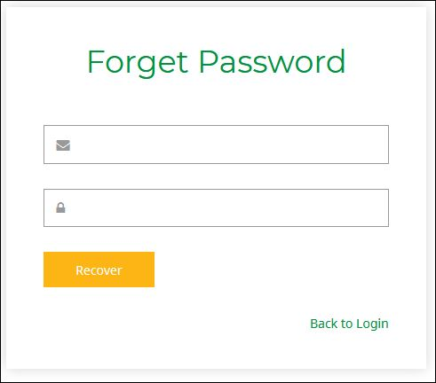

Figure 7 forget password page

In forget password page have to enter mobile number for that particular username. Figure 8 shows enter incorrect mobile number, and figure 9 shows enter correct mobile number.

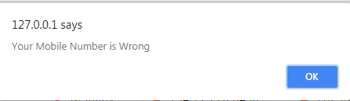

Figure 8 Incorrect mobile number

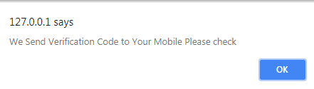

Figure 9 Correct mobile number

After entering correct mobile number and get verification code via mobile. Then enter verification code as shown figure 10

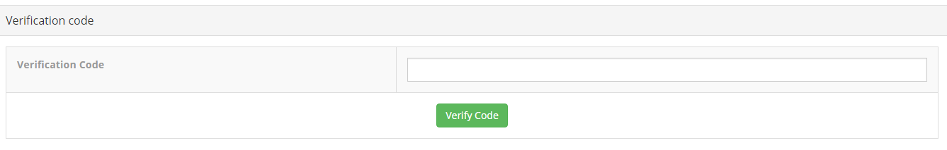

Figure 10 Enter verification code

Entering verification code is wrong, system shows error message and it leads to home page shown figure 11 and enter correct verification code, show message as figure 12 then leads to change password page.

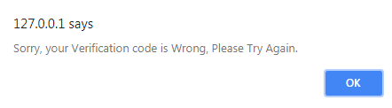

Figure 11 Enter incorrect verification code

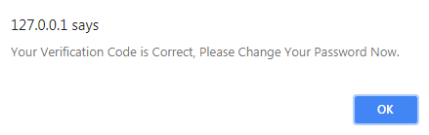

Figure 12 Enter correct verification code

Enter new password and confirm new password in forget password change page shown as figure C .13

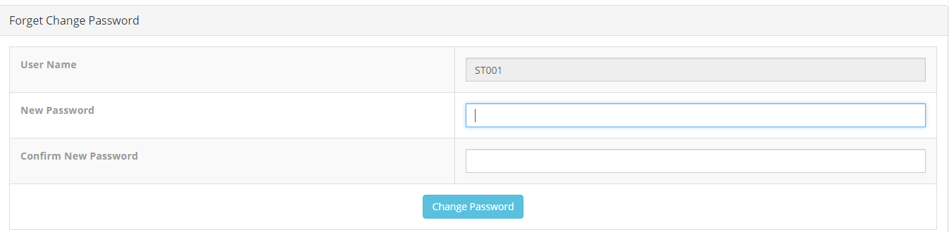

Figure 13 Forget change password

In that page enter new password and confirm new password are mismatch, system show error message as shown figure 14 and leads to home page.

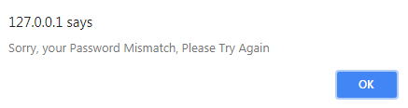

Figure 14 Enter mismatch password

Enter new password and confirm new password are correct, the system update new password and go to login page.

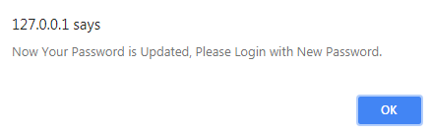

Figure 15 Enter correct password

REGISTER AS CUSTOMER

Click “Register as customer” link from home page, a customer can register him/ herself. (Figure 16)

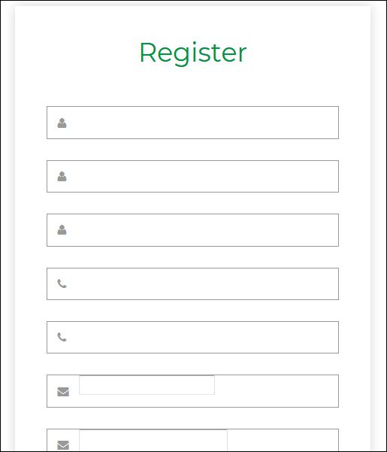

Figure 16 Register as customer

Click “Register” button after filled form. The system send verification code to mobile number (Figure 17) and go to register verification code page. (Figure 18)

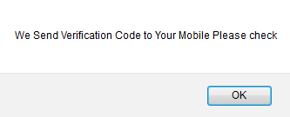

Figure 17 Send verification code to customer

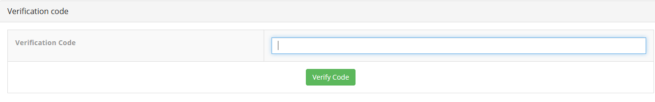

Figure 18 Enter verification code - customer

If enter incorrect verification code delete all data for the particular customer from database and go to home page (Figure 19). If enter correct verification code, the system register the customer and go to login page. The system gives username and password for the customer. (Figure 20)

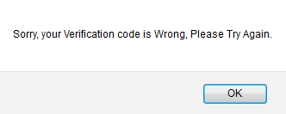

Figure 19 Enter incorrect verification code - customer

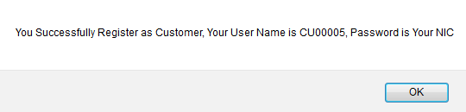

Figure 20 Registered as customer

ACCESS BY GUEST

A guest can access the home page and view the products. Guest can directly select a product to add card or select quick view and select add card. In quick view page, a guest can view all details of a product. Select to add to card menu, there should be show a popup menu and select quantity. The system calculate total price and displayed it.

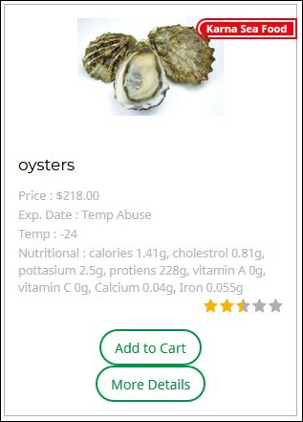

Figure 21 Product detail

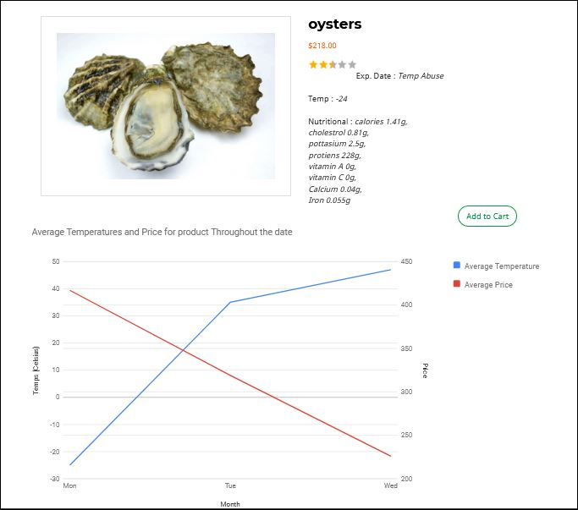

Figure 22 Quick view

If click add to card button, it leads to checkout page. (Figure 48)

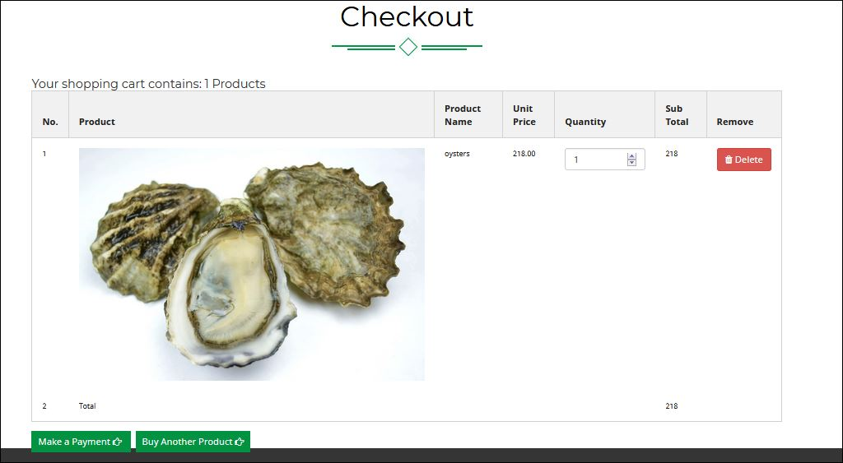

Figure 23 Checkout page

In checkout page, guest change amount of quantity and delete the selected product. Click “buy another product” button, guest can browse more product and select those products too.

Finally if click “Make payment” button, system check login or not. If it is not login go to login page. After user login system leads to again checkout page. Otherwise system goes to bill page.